Forgiveness
2 Samuel 19:16-23

1. Forgiveness _________ (v 19-20)

2. (v 21) Forgiveness _______________

3. Forgiveness ____________ (v 22-23)

4. Forgiveness _____________
(Matt 5:9-15)

10/09: Steve Drake – 706-897-3754

10/09: Mick & Shirley Cox

10/16: Roger & Deloria Conner

10/09- 9:30: Nancy Ellingsworth & Jessica Frechette
10:45: Shirley Roberson & Abby Tippens
10/16- 9:30: Nancy Ellingsworth & Sara Davis
10:45: Mona Kern & Addison Kennedy

10/09 - Megan Henry & Connie Collins
Asst: Houston Henry

10/16 – DiAnne Bennett & Kelsey Cline
Asst: Lane Kennedy

10/02/22
Worship Attendance 157
Sunday School Attendance 98

Budget Goal per month $29,470.26
Given this Month $12,352.80
Given Last Week $12,352.80

Pastor: Rev. Paul Holcombe
Communication Coordinator: Duane Manders
Phone: (706) 745-4350
Email: office@antiochga.org

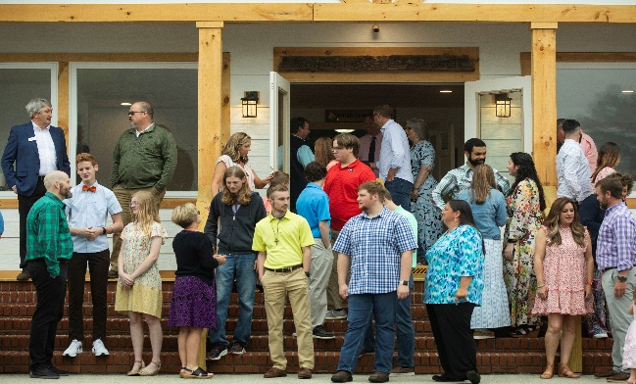
Welcome to Antioch!

October 09, 2022

Sunday

9:45 am - Sunday School
11:00 am - Worship Service
5:00 pm - Life Groups

Wednesday

6:00 - 7:30 pm - Nursery
6:00 - 7:30 pm - AWANA
& Worship Kidstyle
6:00 - 7:30 pm - Youth
6:00 - 7:30 pm - Adult Bible Studies

Soli Deo Gloria!

Welcome & Announcements
Worship & Praise
Come Thou Fount of Every Blessing

One Thing Remains

Goodness of God

**Kids released for Children's Church**

His Mercy is More
Sermon
Forgiveness
2 Samuel 19:16-23

Paul Holcombe

Worship & Praise

Communion

Benediction

* No Wednesday Night Services this week, enjoy Fall Break.

* Women On Mission will meet on Tuesday @ 3pm in the FLC. Please email DiAnne Bennett at dibennettblr@aol.com for more information.

* Fall Festival is on its way! We will celebrate October 30th @ 5pm. Inflatables, games, costume contest, and more!

* Veterans Day Luncheon is Sunday, November 13th @ 1pm in the FLC. Please RSVP to Larry Davis by November 9th.

* Christmas Dinner, Communion, and Children’s Play is Sunday, December 11th @ 5pm.

* No Children’s Christmas Play Practice this Sunday!

* Youth vs Parents Field Day is October 23rd @ 4pm

* Follow us for Youth updates:
Instagram: @ASM_BLAIRSVILLE
Facebook: @AntiochStudentMinistries
Remind Text: text @ASMILD to 81010

* Men’s Prayer Breakfast is Mondays @7:30 am.

* The Choir wants your voice! Practices are Mondays @7pm. Practice in September will be on the 26^{th&} & in October on the 3rd, 17th, & 24th @ 7:00pm.

* We offer two separate Ladies Bible Studies. Join us @10am on Tuesdays or @5:30pm on Thursdays. Contact the church office for more information.

* Adult Bible Studies on Wednesday @ 6pm: Study in II John & Psalms.

* Conspicuous, the College & Career Life Group, meets Thursday 7-9pm. Contact the church office for more information.

* Ways to Give – Drop it in the offering plates at each door, By Mail, or Online at antiochga.org

