
God’s Hands
2 Samuel 24:1-17

1. Learn to ______ (v 1)

2. (v 3) Learn to _________

3. Learn to _________ (v 11-14)

4. Learn to ________ (v 15-17)



10/23: Steve Drake – 772-473-0618


10/23: Jim & Bobbie Ackles

10/30: Steve Drake & Gary Cook


10/23- 9:30: Nancy Ellingsworth & Susan Karnes
10:45: Biz Roesch & Chelsea Barton
10/30- 9:30: Nancy Ellingsworth & Christina Pokrywa
10:45: Terri Linton & Shirley Roberson



10/23 - DiAnne Bennett & Kelsey Cline
Asst: Lane Kennedy

10/30 – Kevin & Alicia Payne
Asst: Hayden Payne



10/16/22
Worship Attendance 164
Sunday School Attendance 101

Budget Goal per month $29,470.26
Given this Month $26,546.33
Given Last Week $6,782.16


Pastor: Rev. Paul Holcombe
Communications Coordinator: Duane Manders
Phone: (706) 745-4350
Email: office@antiochga.org



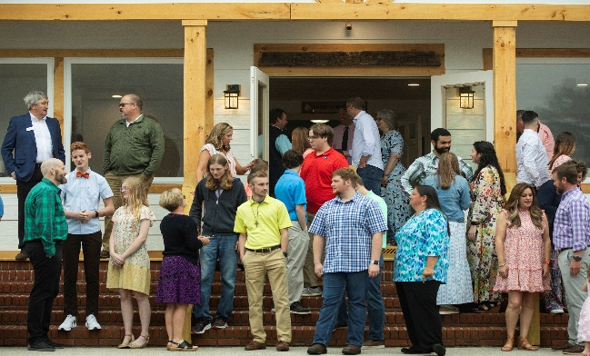
Welcome to Antioch!

October 23, 2022

Sunday

9:45 am - Sunday School
11:00 am - Worship Service
5:00 pm - Life Groups

Wednesday

6:00 - 7:30 pm - Nursery
6:00 - 7:30 pm - AWANA
& Worship Kidstyle
6:00 - 7:30 pm - Youth
6:00 - 7:30 pm - Adult Bible Studies

Soli Deo Gloria!


Scripture Reading
I Love You, Lord
Announcements
Worship & Praise
Blessed Assurance

He’s God

**Kids released for Children's Church**

Please Forgive Me
Sermon
God’s Hands

Rev. Paul Holcombe

Worship & Praise

Just As I Am

Benediction



* Fall Festival is on its way! We will celebrate October 30th @ 5pm. Inflatables, games, costume contest, and more! We need candy & trunks

* Veterans Day Luncheon is Sunday, November 13th @ 1pm in the FLC. Please RSVP to Larry Davis @ 772-473-0618 by November 9th.

* Can You Sew? Please meet on stage after service to volunteer to make Christmas play costumes.





* Christmas Dinner, Communion, and Children’s Play is Sunday, December 11th @ 5pm.

* Wreaths Across America is a program where wreaths are placed on the graves of deceased veterans. Contact Roger Conner @ 850-585-0742 or Terry Kintz @ 706-897-5711 for more information.



* Calling all Children! Christmas play practice continues tonight from 4:30-6pm. Performance will be during our Family Christmas on the evening of December 11th. Please see Danita for more information.

* Youth vs Parents Field Day is today @ 4pm

* Follow us for Youth updates:
Instagram: @ASM_BLAIRSVILLE
Facebook: @AntiochStudentMinistries
Remind Text: text @ASMILD to 81010



* Men’s Prayer Breakfast is Mondays @7:30 am.

* The Choir wants your voice! Practices are Mondays @7pm. Practice in October on the 24th @ 7:00pm.

* We offer two separate Ladies Bible Studies. Join us @10am on Tuesdays or @5:30pm on Thursdays. Contact the church office for more information.

* Adult Bible Studies on Wednesday @ 6pm: Study in II John & Psalms.

* Conspicuous, the College & Career Life Group, meets Thursday 7-9pm. Contact the church office for more information.

* Ways to Give – Drop it in the offering plates at each door, By Mail, or Online at antiochga.org

