
Think Different
2 Samuel 6:16-23

1. Think different about __________
(v 16)

2. (v 16-19) Think different about ___________
.

3. Think different about ___________
(v 20-21)

4. Think different about ___________ (v 20)



9/11: Larry Davis – 772-473-0618


9/11: Mick & Shirley Cox

9/18: Roger & Deloria Conner


9/11- 9:30: Nancy Ellingsworth & Abby Tippens
10:45: Shirley Roberson & Abby Tippens
9/18- 9:30: Nancy Ellingsworth & Sara Davis
10:45: Pat Rudd & Addison Kennedy



9/11 - Megan Henry & Connie Collins
Asst: Houston Henry

9/18 – Kelley Manders & Mickey Ward
Asst: Caroline Karnes



09/04/22
Worship Attendance 178
Sunday School Attendance 96

Budget Goal per month $29,470.26
Given this Month $9,041.00
Given Last Week $9,041.00


Pastor: Rev. Paul Holcombe
Communication Coordinator: Duane Manders
Phone: (706) 745-4350
Email: office@antiochga.org



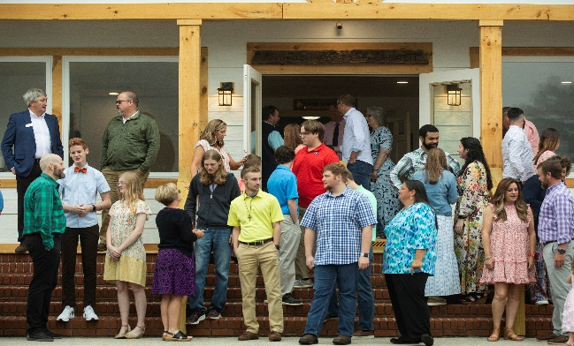
Welcome to Antioch!

September 11, 2022

Sunday

9:45 am - Sunday School
11:00 am - Worship Service
5:00 pm - Life Groups

Wednesday

6:00 - 7:30 pm - Nursery
6:00 - 7:30 pm - AWANA
& Worship Kidstyle
6:00 - 7:30 pm - Youth
6:00 - 7:30 pm - Adult Bible Studies

Soli Deo Gloria!


We Have Come Into This House
Welcome & Announcements
Worship & Praise
Glorify Thy Name

Yes, I Will

**Kids released for Children's Church**

Heart of Worship
Sermon
Think Different
2 Samuel 6:16-23

Paul Holcombe

Worship & Praise
Heart of Worship

Benediction



* Sunday School Teacher Meeting is September 18th immediately following the Worship Service. Meeting will be in the FLC Kitchen & lunch is provided.

* State Missions Offering will be taken up on September 25th. This year’s theme is “Hope for a World in Despair”. Our goal is $2500.

* Vision Night is coming September 25th @ 5pm in the Sanctuary. Also, our Quarterly Business Meeting will take place. Family Dinner to follow in the FLC.

* Ushers Meeting is October 2nd immediately following the Worship Service. Meeting will be in the FLC Kitchen & lunch is provided.




* Women On Mission will meet on October 11th @ 3pm in the FLC. You can email DiAnne Bennett at dibennettblr@aol.com for more information.

* Fall Festival is on its way! We will celebrate October 30th @ 5pm. Inflatables, games, costume contest, and more!



* Calling all Children! Christmas play practice begins tonight from 4:30-6pm. Performance will be during our Family Christmas on the evening of December 11th. Please see Danita for more information.

* Youth Life Group meets tonight. See your Youth Leaders for more info.

* Follow us for Youth updates:
Instagram: @ASM_BLAIRSVILLE
Facebook: @AntiochStudentMinistries
Remind Text: text @ASMILD to 81010



* Men’s Prayer Breakfast is Mondays @7:30 am.

* The Choir wants your voice! Practices are Mondays @7pm. Practice in September will be on the 12th & 26th @ 7:00pm.

* We offer two separate Ladies Bible Studies. Join us @10am on Tuesdays or @5:30pm on Thursdays. Contact the church office for more information.

* Adult Bible Studies on Wednesday @ 6pm: Study in I John & Psalms.

* Conspicuous, the College & Career Life Group, meets Thursday 7-9pm. Contact the church office for more information.

* Ways to Give – Drop it in the offering plates at each door, By Mail, or Online at antiochga.org

