Grief
2 Samuel 12:15-25

I. __________ in Our Grief

1. Is it my ________? (v 15)

2. (v 16-17) Is God ____________?

3. Is there a __________ ______?
(v 18-20)

II. Weathering the ________

1. (v 17-18) Choose ________ People for ________ Times

2. Remember the ___________
(v 21-23)

3. (v 24-25) Depend on a
______________ God

9/25: Mike Bittel – 706-835-7555

9/25: Jim & Bobbie Ackles

10/02: Steve Drake & Gary Cook

9/25- 9:30: Nancy Ellingsworth & Susan Karnes
10:45: Nancy Ellingsworth & Sara Bittel
10/02- 9:30: Nancy Ellingsworth & Christina Pokrywa
10:45: Annie Kintz & Mona Kern

9/25 - Kelley Manders & Mickey Ward
Asst: Caroline Karnes

10/02 – Kevin & Alicia Payne
Asst: Hayden Payne

09/18/22
Worship Attendance 152
Sunday School Attendance 87

Budget Goal per month $29,470.26
Given this Month $22,346.89
Given Last Week $3033.43

Pastor: Rev. Paul Holcombe
Communication Coordinator: Duane Manders
Phone: (706) 745-4350
Email: office@antiochga.org

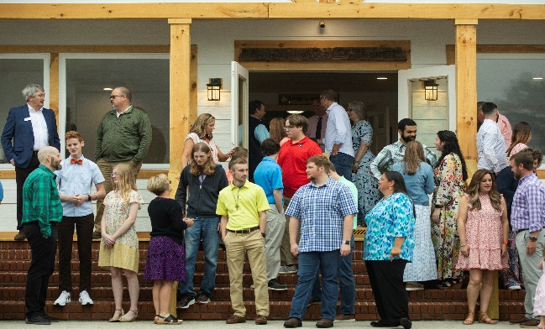
Welcome to Antioch!

September 25, 2022

Sunday

9:45 am - Sunday School
11:00 am - Worship Service
5:00 pm - Life Groups

Wednesday

6:00 - 7:30 pm - Nursery
6:00 - 7:30 pm - AWANA
& Worship Kidstyle
6:00 - 7:30 pm - Youth
6:00 - 7:30 pm - Adult Bible Studies

Soli Deo Gloria!

Thank You for the Cross
Welcome & Announcements
Worship & Praise
It is Well

What Mercy Did for Me

**Kids released for Children's Church**

Praise You in This Storm
Sermon
Grief
2 Samuel 12:15-25

Paul Holcombe

Worship & Praise
Praise You in This Storm

Benediction

* State Missions Offering will be taken up on today. This year’s theme is “Hope for a World in Despair”. Our goal is $2500.

* Vision Night is coming tonight @ 5pm in the Sanctuary. Also, our Quarterly Business Meeting will take place. Family Dinner to follow in the FLC.

* Ushers Meeting is October 2nd immediately following the Worship Service. Meeting will be in the FLC Kitchen & lunch is provided.

* Church Celebration/Business Meeting will be October 9th @ 5pm in the FLC. Look forward to seeing you there!

* Women On Mission will meet on October 11th @ 3pm in the FLC. You can email DiAnne Bennett at dibennettblr@aol.com for more information.

* Fall Festival is on its way! We will celebrate October 30th @ 5pm. Inflatables, games, costume contest, and more!

* Calling all Children! Christmas play practice begins tonight from 4:30-6pm. Performance will be during our Family Christmas on the evening of December 11th. Please see Danita for more information.

* Youth Life Group meets tonight. See your Youth Leaders for more info.

* Follow us for Youth updates:
Instagram: @ASM_BLAIRSVILLE
Facebook: @AntiochStudentMinistries
Remind Text: text @ASMILD to 81010

* Men’s Prayer Breakfast is Mondays @7:30 am.

* The Choir wants your voice! Practices are Mondays @7pm. Practice in September will be on the 26^{th&} & in October on the 3rd, 17th, & 24th @ 7:00pm.

* We offer two separate Ladies Bible Studies. Join us @10am on Tuesdays or @5:30pm on Thursdays. Contact the church office for more information.

* Adult Bible Studies on Wednesday @ 6pm: Study in I John & Psalms.

* Conspicuous, the College & Career Life Group, meets Thursday 7-9pm. Contact the church office for more information.

* Ways to Give – Drop it in the offering plates at each door, By Mail, or Online at antiochga.org

