Why am I Depressed?
I Kings 19:1-18

I. Why is Elijah Depressed?
1. ____________ (v 1-2)
2. _______ (v 3-4)
II. Walking Out of the Cave
1. (v 6-9) ________ Up
2. Learn to ________ (v 8)
3. __________ the Vacuum of ______
4. _______ and _________ (v 11-13)
5. (v 16-18) Get ________

11/06: Mike Bittel – 706-825-7555

11/13: Roger & Deloria Conner
11/20: Jim & Bobbie Ackles

11/13- 9:30: Nancy Ellingsworth & Jessica Frechette
10:45: Shirley Roberson & Abby Tippens
11/20- 9:30: Nancy Ellingsworth & Sara Davis
10:45: Pat Rudd & Sara Bittel

11/13 - Kelley Manders & Mickey Ward
Asst: Caroline Karnes

11/20 – DiAnne Bennett & Kelsey Cline
Asst: Lane Kennedy

11/06/22
Worship Attendance 158
Sunday School Attendance 112

Budget Goal per month $29,470.26
Given this Month $9,455.35
Given Last Week $9,455.35

Pastor: Rev. Paul Holcombe
Communications Coordinator: Duane Manders
Phone: (706) 745-4350
Email: office@antiochga.org

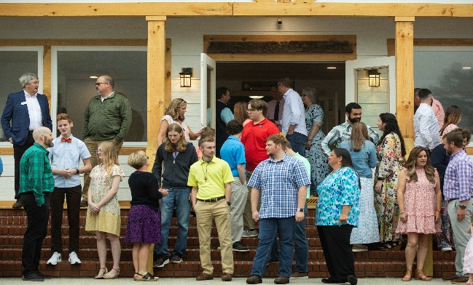
Welcome to Antioch!

November 13, 2022

Sunday

9:45 am - Sunday School
11:00 am - Worship Service
5:00 pm - Life Groups

Wednesday

6:00 - 7:30 pm - Nursery
6:00 - 7:30 pm - AWANA
& Worship Kidstyle
6:00 - 7:30 pm - Youth
6:00 - 7:30 pm - Adult Bible Studies

Soli Deo Gloria!

Announcements

Worship & Praise
Lord Prepare Me to be a Sanctuary
What a Friend We have in Jesus
This Blood

**Kids released for Children's Church**
Amazing Grace, My Chains are Gone
Sermon
Why am I Depressed?

Paul Holcombe

Worship & Praise

Sweet Hour of Prayer

Benediction

* Veterans Day Luncheon is Today, @1pm in the FLC.

* Have you ever asked Why? Next Sunday, we continue our sermon series. Next up, “Why am I Angry?” from 1 Samuel 18:1-16. Pray, Read, & Invite!

* Thanksgiving is on its way! Due to the holiday, there will be no Wednesday night services on November 23rd.

* Christmas Dinner, Communion, and Children’s Play is Sunday, December 11th @4pm.

* Wreaths Across America is a program where wreaths are placed on the graves of deceased veterans. Contact Roger Conner @ 850-585-0742 or Terry Kintz @ 706-897-5711 for more information.

* Attention Parents! There has been a change to the ages for Nursery and Children’s Church. Nursery ages are birth – 3yrs old. Children’s Church ages are 4-7yrs old.

* Strength to Stand second deposits are due Wednesday, Dec. 7th. $33.33 is due to reserve your student’s spot.

* Follow us for Youth updates:
Instagram: @ASM_BLAIRSVILLE
Facebook: @AntiochStudentMinistries
Remind Text: text @ASMILD to 81010

* Men’s Prayer Breakfast is Mondays @7:30 am.

* The Choir wants your voice! Practices are Mondays @7pm.

* We offer two separate Ladies Bible Studies. Join us @10am on Tuesdays or @5:30pm on Thursdays. Contact the church office for more information.

* Women On Mission - meets every 2nd Tuesday of the month @ 3pm in the FLC Kitchen

* Adult Bible Studies on Wednesday @ 6pm.

* Conspicuous, the College & Career Life Group, meets Thursday 7-9pm. Contact the church office for more information.

* Ways to Give – Drop it in the offering plates at each door, By Mail, or Online at antiochga.org

