

Why am I Angry?
I Samuel 18:1-16

I. Why is Saul Angry?
1. Saul is __________ (v 1-4)
2. (v 5-7) Saul was _____________
3. (v 8-11) Saul was ____________
4. Saul was ___________ (v 12-16)
II. Stop Hurling Spears
1. (v 4) Phone a ___________
2. ___________ Gratitude (v 6)
3. Search you ____________ (v 8)
4. ________ with _______ (v 14)



11/20: Gary Cook – 706-994-4902


11/20: Jim & Bobbie Ackles
11/27: Steve Drake & Gary Cook

11/20- 9:30: Nancy Ellingsworth & Sara Davis
10:45: Pat Rudd & Shirley Roberson
11/27- 9:30: Nancy Ellingsworth & Susan Karnes
10:45: Biz Roesch & Chelsea Barton

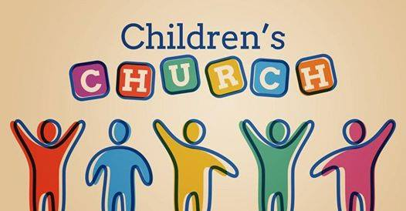

11/20 - DiAnne Bennett & Kelsey Cline
Asst: Lane Kennedy

11/27 – Kevin & Alicia Payne
Asst: Hayden Payne



11/13/22
Worship Attendance 146
Sunday School Attendance 95

Budget Goal per month $29,470.26
Given this Month $16,598.54
Given Last Week $7,143.19


Pastor: Rev. Paul Holcombe
Communications Coordinator: Duane Manders
Phone: (706) 745-4350
Email: office@antiochga.org



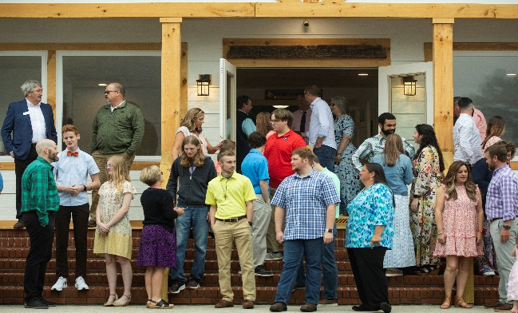
Welcome to Antioch!

November 20, 2022

Sunday

9:45 am - Sunday School
11:00 am - Worship Service
5:00 pm - Life Groups

Wednesday

6:00 - 7:30 pm - Nursery
6:00 - 7:30 pm - AWANA
& Worship Kidstyle
6:00 - 7:30 pm - Youth
6:00 - 7:30 pm - Adult Bible Studies

Soli Deo Gloria!


Announcements

Worship & Praise
Give Thanks #770
Graves into Gardens
Thank You Jesus for the Blood

**Kids released for Children's Church**
Gratitude
Sermon
Why am I Angry?

Paul Holcombe

Worship & Praise

Worthy is the Lamb

Benediction



* Thank You to our veterans for attending the luncheon last week. Thank you to all that decorated, cooked & served to make the event a success.

* Have you ever asked Why? Next Sunday, we conclude our sermon series. Next up, “Why am I Anxious?” from II Chronicles 20:1-23. Pray, Read, & Invite!

* Thanksgiving is on its way! Due to the holiday, there will be no Wednesday night services on November 23rd.





* Christmas Dinner, Communion, and Children’s Play is Sunday, December 11th @3pm.

* Wreaths Across America is a program where wreaths are placed on the graves of deceased veterans. Contact Roger Conner @ 850-585-0742 or Terry Kintz @ 706-897-5711 for more information.


* Attention Parents! There has been a change to the ages for Nursery and Children’s Church. Nursery ages are birth – 3yrs old. Children’s Church ages are 4-7yrs old.

* Strength to Stand second deposits are due Wednesday, Dec. 7th. $33.33 is due to reserve your student’s spot.

* Follow us for Youth updates:
Instagram: @ASM_BLAIRSVILLE
Facebook: @AntiochStudentMinistries
Remind Text: text @ASMILD to 81010



* Men’s Prayer Breakfast is Mondays @7:30 am.

* The Choir wants your voice! Practices are Mondays @7pm.

* We offer two separate Ladies Bible Studies. Join us @10am on Tuesdays or @5:30pm on Thursdays. Contact the church office for more information.

* Women On Mission - meets every 2nd Tuesday of the month @ 3pm in the FLC Kitchen

* Adult Bible Studies on Wednesday @ 6pm.

* Conspicuous, the College & Career Life Group, meets Thursday 7-9pm. Contact the church office for more information.

* Ways to Give – Drop it in the offering plates at each door, By Mail, or Online at antiochga.org

