

Wise Women
Matthew 1:1-17

I. Life in a Foolish World
1. World of ______________ (v 3)
2. (v 3) World of ___________
3. (v 5) World of _____________
4. World of _____________ (v 6)
5. (v 16) World of the _____________
II. Wisdom from God’s Family Tree
1. God wants a ____________ (v 1)
2. (v 1) God replaces _______________
3. (v 16) God was __________
4. God gives __________ ________ (v 17)



12/04: Kevin Payne – 706-400-1591


12/04: Mick & Shirley Cox
12/11: Roger & Deloria Conner

12/04- 9:30: Nancy Ellingsworth & Christina Pokrywa
10:45: Annie Kintz & Mona Kern
12/11- 9:30: Nancy Ellingsworth & Jessica Frechette
10:45: Abby Tippens & Stephanie Chastain



12/04 - Megan Henry & Connie Collins
Asst: Houston Henry

12/11 – Kelley Manders & Mickey Ward
Asst: Caroline Karnes



11/27/22
Worship Attendance 145
Sunday School Attendance 87

Budget Goal per month $29,470.26
Given this Month $25,141.94
Given Last Week $4,207.35


Pastor: Rev. Paul Holcombe
Communications Coordinator: Duane Manders
Phone: (706) 745-4350
Email: office@antiochga.org



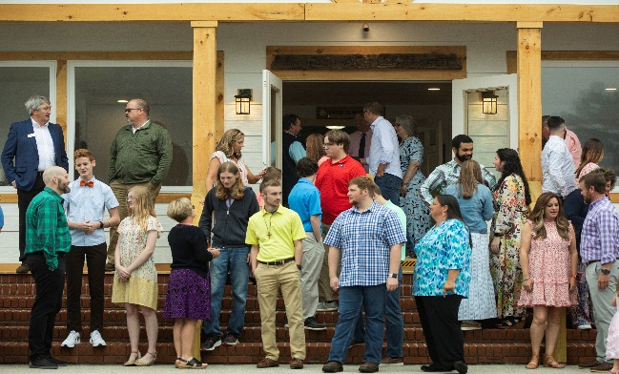
Welcome to Antioch!

December 04, 2022

Sunday

9:45 am - Sunday School
11:00 am - Worship Service
5:00 pm - Life Groups

Wednesday

6:00 - 7:30 pm - Nursery
6:00 - 7:30 pm - AWANA
& Worship Kidstyle
6:00 - 7:30 pm - Youth
6:00 - 7:30 pm - Adult Bible Studies

Soli Deo Gloria!


Announcements

Worship & Praise
Go Tell It on the Mountain #181
O Little Town of Bethlehem #169
Jireh
**Kids released for Children's Church**
The Hand of Sweet Release
Sermon
Wise Women

Paul Holcombe

Worship & Praise

Softly and Tenderly #337

Benediction



* Lottie Moon Offering for International Missions is being collected from now until January 1st. Please pray about how you might help make our goal of $4000 a reality.

* Christmas Dinner, Communion, and Children’s Play is next Sunday, December 11th @ 3pm. Please plan to join us as we celebrate the Christmas season together.

* First Christmas continues next Sunday. Next up, The King is Coming from Luke 1:26-38. Pray, Read, Invite!





* Business Meeting will be held Sunday, January 8th. Pace will be our featured ministry.

* WOM’s Local Mission Project is focused on the Isaiah 117 House. Please take a list and consider how you might contribute to this local ministry. Items will be collected until March 1st.



* Attention Parents! There has been a change to the ages for Nursery and Children’s Church. Nursery ages are birth – 3yrs old. Children’s Church ages are 4-7yrs old.

* Strength to Stand second deposits are due Wednesday, Dec. 7th. $33.33 is due to reserve your student’s spot.

* Follow us for Youth updates:
Instagram: @ASM_BLAIRSVILLE
Facebook: @AntiochStudentMinistries
Remind Text: text @ASMILD to 81010



* Men’s Prayer Breakfast is Mondays @7:30 am.

* The Choir wants your voice! Practices are Mondays @7pm.

* We offer two separate Ladies Bible Studies. Join us @10am on Tuesdays or @5:30pm on Thursdays. Contact the church office for more information.

* Women On Mission - meets every 2nd Tuesday of the month @ 3pm in the FLC Kitchen

* Adult Bible Studies on Wednesday @ 6pm.

* Conspicuous, the College & Career Life Group, meets Thursday 7-9pm. Contact the church office for more information.

* Ways to Give – Drop it in the offering plates at each door, By Mail, or Online at antiochga.org

