The King is Coming
Luke 1:26-38

I. Truths about the _______
1. The King will _________ ____
your life (v 26-30)
2. (v 31-33) The King will _______
your life
3. (v 34-37) The King will _______________ your life
II. _________ with the King
1. Trade ________ for ________ (v 30)
2. (v 32-33) Trade Eternity ___________ for Eternity _______
3. Trade______ Kingdom for ____ (v 38)

12/11: Steve Drake – 706-897-3754

12/11: Roger & Deloria Conner
12/18: Jim & Bobbie Ackles

12/11- 9:30: Nancy Ellingsworth & Jessica Frechette
10:45: Abby Tippens & Stephanie Chastain
12/18- 9:30: Nancy Ellingsworth & Sara Davis
10:45: Pat Rudd & Addison Kennedy

12/11 - Kelley Manders & Mickey Ward
Asst: Caroline Karnes

12/18 – DiAnne Bennett & Kelsey Cline
Asst: Lane Kennedy

12/04/22
Worship Attendance 176
Sunday School Attendance 100

Budget Goal per month $29,470.26
Given this Month $14,583.04
Given Last Week $14,583.04

Pastor: Rev. Paul Holcombe
Communications Coordinator: Duane Manders
Phone: (706) 745-4350
Email: office@antiochga.org

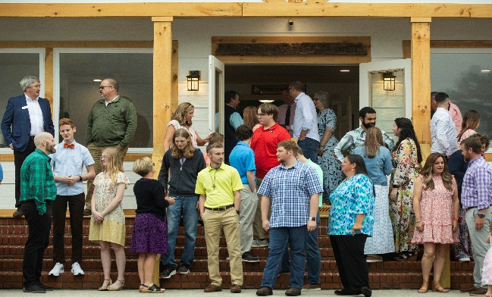
Welcome to Antioch!

December 11, 2022

Sunday

9:45 am - Sunday School
11:00 am - Worship Service
5:00 pm - Life Groups

Wednesday

6:00 - 7:30 pm - Nursery
6:00 - 7:30 pm - AWANA
& Worship Kidstyle
6:00 - 7:30 pm - Youth
6:00 - 7:30 pm - Adult Bible Studies

Soli Deo Gloria!

Announcements

Worship & Praise
Hark! The Herald Angels Sing #191
A Holy Day
Prince of Peace
**Kids released for Children's Church**
Noel
Sermon
A Christmas Carol

Paul Holcombe

Worship & Praise

Turn Your Eyes Upon Jesus #327

Benediction

* Lottie Moon Offering is being collected until January 1st. Our goal is $4000.

* Christmas Dinner, Communion, and Children’s Play is today at 3pm. Dinner begins in the FLC with the play to follow.

* Wreaths will be place to honor our Veterans next Saturday, December 17th at 10am. Please join us as we celebrate their service.

* Christmas Day Worship Service will be at 10am. There will be no Sunday School, Nursery, or Children’s Church.

* Business Meeting will be held Sunday, January 8th. Pace will be our featured ministry.

* A new Sunday night Study begins Sunday, January 22nd at 4pm. Join us for this 7-week series, Taming the Tongue: How the Gospel Transforms Our Talk. Please contact the church office or Pastor Paul to request a book for the class.

* WOM’s Local Mission Project is focused on the Isaiah 117 House. Items will be collected until March 1st.

* Attention Parents! There has been a change to the ages for Nursery and Children’s Church. Nursery ages are birth – 3yrs old. Children’s Church ages are 4-7yrs old.

* Strength to Stand second deposits are due Wednesday, Dec. 7th. $33.33 is due to reserve your student’s spot.

* Follow us for Youth updates:
Instagram: @ASM_BLAIRSVILLE
Facebook: @AntiochStudentMinistries
Remind Text: text @ASMILD to 81010

* Men’s Prayer Breakfast is Mondays @7:30 am.

* The Choir wants your voice! Practices are Mondays @7pm.

* We offer two separate Ladies Bible Studies. Join us @10am on Tuesdays or @5:30pm on Thursdays. Contact the church office for more information.

* Women On Mission - meets every 2nd Tuesday of the month @ 3pm in the FLC Kitchen

* Adult Bible Studies on Wednesday @ 6pm.

* Conspicuous, the College & Career Life Group, meets Thursday 7-9pm. Contact the church office for more information.

* Ways to Give – Drop it in the offering plates at each door, By Mail, or Online at antiochga.org

