

A Christmas Carol
Luke 1:46-55

I. What Every ____________ ________ Needs
1. A ______ that Magnifies (v 46-47)
2. (v 48-49) A ______ that Descends
3. (v 50) __________ that Overwhelms
II. The _________ of Christmas
1. The _______ are __________ (v 51-53)
2. A ___________ Family (v 54-55)
3. A _______ that ____________



12/18: Larry Davis – 772-473-0618


12/18: Roger & Deloria Conner
12/25: Jim & Bobbie Ackles


12/18- 9:30: Nancy Ellingsworth & Sara Davis
10:45: Pat Rudd & Addison Kennedy
12/25- No Nursery



12/18 - DiAnne Bennett & Kelsey Cline
Asst: Lane Kennedy

12/25 – No Children’s Church



12/11/22
Worship Attendance 178
Sunday School Attendance 92

Budget Goal per month $29,470.26
Given this Month $24,272.92
Given Last Week $9,689.88


Pastor: Rev. Paul Holcombe
Communications Coordinator: Duane Manders
Phone: (706) 745-4350
Email: office@antiochga.org



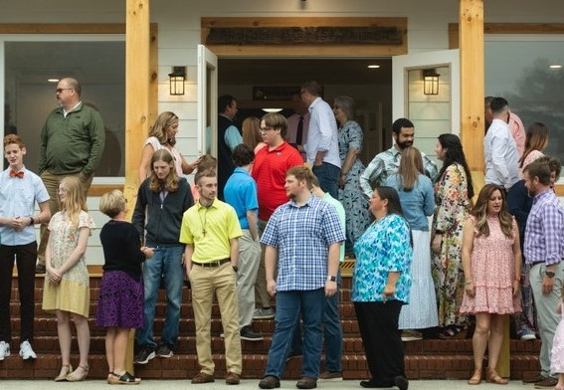
Welcome to Antioch!

December 18, 2022

Sunday

9:45 am - Sunday School
11:00 am - Worship Service
5:00 pm - Life Groups

Wednesday

6:00 - 7:30 pm - Nursery
6:00 - 7:30 pm - AWANA
& Worship Kidstyle
6:00 - 7:30 pm - Youth
6:00 - 7:30 pm - Adult Bible Studies

Soli Deo Gloria!


Announcements

Worship & Praise
The First Noel #167
It Came Upon a Midnight Clear #168
Silent Night (Heavenly Peace)
Away in a Manger w/ Worthy is Your Name
**Kids released for Children's Church**
Light Has Come
Sermon
A Christmas Carol

Paul Holcombe

Worship & Praise

I Need Thee Every Hour #600

Benediction



* Lottie Moon Offering is being collected until January 1st. Our goal is $4000.

* Wreaths will be place to honor our Veterans tomorrow, December 19th at 10am. Please join us as we celebrate their service.

* Christmas Day Worship Service will be at 10am. There will be no Sunday School, Nursery, or Children’s Church.




* Business Meeting will be held Sunday, January 8th. Pace will be our featured ministry.

* A new Sunday night Study begins Sunday, January 22nd at 4pm. Join us for this 7-week series, Taming the Tongue: How the Gospel Transforms Our Talk. Please contact the church office or Pastor Paul to request a book for the class.

* WOM’s Local Mission Project is focused on the Isaiah 117 House. Items will be collected until March 1st.



* Attention Parents! There has been a change to the ages for Nursery and Children’s Church. Nursery ages are birth – 3yrs old. Children’s Church ages are 4-7yrs old.

* Strength to Stand second deposits are due Wednesday, Dec. 7th. $33.33 is due to reserve your student’s spot.

* Follow us for Youth updates:
Instagram: @ASM_BLAIRSVILLE
Facebook: @AntiochStudentMinistries
Remind Text: text @ASMILD to 81010



* Men’s Prayer Breakfast is Mondays @7:30 am.

* The Choir wants your voice! Practices are Mondays @7pm.

* We offer two separate Ladies Bible Studies. Join us @10am on Tuesdays or @5:30pm on Thursdays. Contact the church office for more information.

* Women On Mission - meets every 2nd Tuesday of the month @ 3pm in the FLC Kitchen

* Adult Bible Studies on Wednesday @ 6pm.

* Conspicuous, the College & Career Life Group, meets Thursday 7-9pm. Contact the church office for more information.

* Ways to Give – Drop it in the offering plates at each door, By Mail, Online at antiochga.org, or text “wind4350” to 888-364-4483

