Guest Speaker
Keith Ivey

SERMON NOTES

01/01: Mike Bittel – 706-835-7555

01/01: Mick & Shirley Cox
01/08: Roger & Deloria Conner

01/01- 9:30: Nancy Ellingsworth & Christina Pokrywa
10:45: Mona Kern & Jaceyallen Elliott
01/08- 9:30: Nancy Ellingsworth & Jessica Frechette
10:45: Abby Tippens & Holly Owenby

01/01 – No Children’s Church

01/08 – No Children’s Church

12/25/22
Worship Attendance 126
Sunday School Attendance

Budget Goal per month $29,470.26
Given this Month $32,117.73
Given Last Week $3,449.69

Pastor: Rev. Paul Holcombe
Communications Coordinator: Duane Manders
Phone: (706) 745-4350
Email: office@antiochga.org

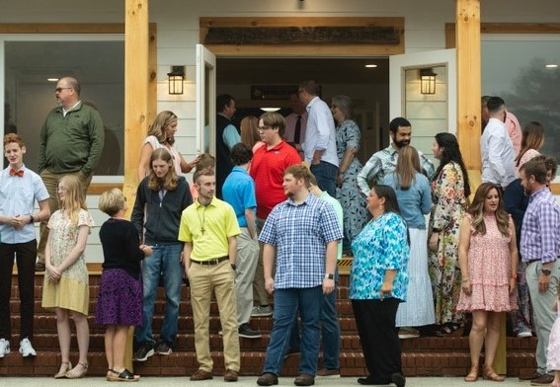
Welcome to Antioch!

January 01, 2023

Sunday

9:45 am - Sunday School
11:00 am - Worship Service
5:00 pm - Life Groups

Wednesday

6:00 - 7:30 pm - Nursery
6:00 - 7:30 pm - AWANA
& Worship Kidstyle
6:00 - 7:30 pm - Youth
6:00 - 7:30 pm - Adult Bible Studies

Soli Deo Gloria!

Announcements

Worship & Praise
Tell Me the Story of Jesus #205
I Heard the Bells on Christmas Day #195
What We Believe
**Kids released for Children's Church**
O Holy Night
Sermon
Guest Speaker
Keith Ivey

Worship & Praise

I Surrender All #486

Benediction

* Lottie Moon Offering is being collected until January 1st. Our goal is $4000.

* No Children’s Church today.

* Business Meeting will be held Sunday, January 8th. Pace will be our featured ministry.

NEXT SERMON SERIES

* A new Sunday night Study begins Sunday, January 22nd at 4pm. Join us for this 7-week series, Taming the Tongue: How the Gospel Transforms Our Talk. Please contact the church office or Pastor Paul to request a book for the class.

* WOM’s Local Mission Project is focused on the Isaiah 117 House. Items will be collected until March 1st.

* Attention Parents! There has been a change to the ages for Nursery and Children’s Church. Nursery ages are birth – 3yrs old. Children’s Church ages are 4-7yrs old.

* Strength to Stand is coming up
January 14th – 16th.

* Follow us for Youth updates:
Instagram: @ASM_BLAIRSVILLE
Facebook: @AntiochStudentMinistries
Remind Text: text @ASMILD to 81010

* Men’s Prayer Breakfast is Mondays @7:30 am.

* The Choir wants your voice! Practices are Mondays @7pm.

* We offer two separate Ladies Bible Studies. Join us @10am on Tuesdays or @5:30pm on Thursdays. Contact the church office for more information.

* Women On Mission - meets every 2nd Tuesday of the month @ 3pm in the FLC Kitchen

* Adult Bible Studies on Wednesday @ 6pm.

* Conspicuous, the College & Career Life Group, meets Thursday 7-9pm. Contact the church office for more information.

* Ways to Give – Drop it in the offering plates at each door, By Mail, Online at antiochga.org, or text “wind4350” to 888-364-4483

