Destruction
Mark 1:21-28

1. Jesus is __________ (v 21)
2. Jesus is ____________ (v 22)
3. (v 23-24) Jesus is _______________
4. Jesus is ______ ( v 25-27)
5. (v 28) Jesus is _________

01/08: Gary Cook – 706-994-4902

01/08: Roger & Deloria Conner
01/15: Jim & Bobbie Ackles

01/08- 9:30: Nancy Ellingsworth & Jessica Frechette
10:45: Abby Tippens & Jaceyallen Elliott
01/15- 9:30: Nancy Ellingsworth & Sara Davis
10:45: Mona Kern & Addison Kennedy

01/08 – No Children’s Church

01/15 – Sara Davis & Emily Floyd
Assistant – Lane Kennedy

01/01/23
Worship Attendance 140
Sunday School Attendance 71

Budget Goal per month $33,712.06
Given this Month $7,346.83
Given Last Week $7,346.83

Pastor: Rev. Paul Holcombe
Communications Coordinator: Duane Manders
Phone: (706) 745-4350
Email: office@antiochga.org

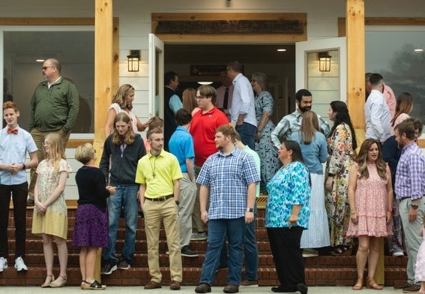
Welcome to Antioch!

January 08, 2023

Sunday

9:45 am - Sunday School
11:00 am - Worship Service
5:00 pm - Life Groups

Wednesday

6:00 - 7:30 pm - Nursery
6:00 - 7:30 pm - AWANA
& Worship Kidstyle
6:00 - 7:30 pm - Youth
6:00 - 7:30 pm - Adult Bible Studies

Soli Deo Gloria!

Announcements

Worship & Praise
Lord, Prepare Me to be a Sanctuary
Leaning on the Everlasting Arms #596
Raise a Hallelujah
**No Children's Church**
We Will Remember
Sermon
Destruction
Rev. Paul Holcombe

Worship & Praise

In Jesus Name (God of Possible)

Benediction

* Thank you for your generosity Lottie Moon Christmas Offering. We collected $4175.00!

* No Children’s Church today. Activity bags are located in the foyer.

* Business Meeting is today at 4pm. Pace will be our featured ministry.

* A New Sunday Night Study begins Sunday, January 22nd at 4pm. Join us for this 7-week series, Taming the Tongue: How the Gospel Transforms Our Talk. Please contact the church office or Pastor Paul to request a book for the class. If you are able to provide childcare please let us know.

* WOM’s Local Mission Project is focused on the Isaiah 117 House. Items will be collected until March 1st.

* Valentine’s Banquet is Saturday,
February 11th @ 6pm for our annual “Loved Beyond Measure” celebration dinner. Everyone is welcome to this time of games, laughs and fellowship! Steak or chicken, along with baked potatoes, salad, and dessert will be served! Please RSVP by February 5th.

* Attention Parents! There has been a change to the ages for Nursery and Children’s Church. Nursery ages are birth – 3yrs old. Children’s Church ages are 4-7yrs old.

* Strength to Stand is coming up
January 14th – 16th.

* Follow us for Youth updates:
Instagram: @ASM_BLAIRSVILLE
Facebook: @AntiochStudentMinistries
Remind Text: text @ASMILD to 81010

* Men’s Prayer Breakfast is Mondays @7:30 am.

* The Choir wants your voice! Practices are Mondays @7pm.

* We offer two separate Ladies Bible Studies. Join us @10am on Tuesdays or @5:30pm on Thursdays. Contact the church office for more information.

* Women On Mission - meets every 2nd Tuesday of the month @ 3pm in the FLC Kitchen

* Adult Bible Studies on Wednesday @ 6pm.

* Conspicuous, the College & Career Life Group, meets Thursday 7-9pm. Contact the church office for more information.

* Ways to Give – Drop it in the offering plates at each door, By Mail, Online at antiochga.org, or text “wind4350” to 888-364-4483

