

Desperate
Mark 2:1-12

1. Paralysis is _____ __________ (v 3-4)
2. (v 6-8) The _________ is the ___________
3. It takes a ___________
( v 3-5)
4. (v 10-12) _________ is the _______________



01/22: Steve Drake – 706-897-3754


01/22: Steve Drake & Gary Cook
01/29: Mick & Shirley Cox

01/22- 9:30: Nancy Ellingsworth & Susan Karnes
10:45: Stephanie Chastain & Chelsea Barton
01/29- 9:30: Nancy Ellingsworth & Christina Pokrywa
10:45: Terri Linton & Pat Rudd



01/22 – Megan Henry & Connie Collins
Assistant – Houston Henry

01/29 – DiAnne Bennett & Kelsey Cline
Assistant – Jayden Karnes



01/15/23
Worship Attendance 151
Sunday School Attendance 101

Budget Goal per month $33,712.06
Given this Month $21,857.87
Given Last Week $5,995.44


Pastor: Rev. Paul Holcombe
Communications Coordinator: Duane Manders
Phone: (706) 745-4350
Email: office@antiochga.org



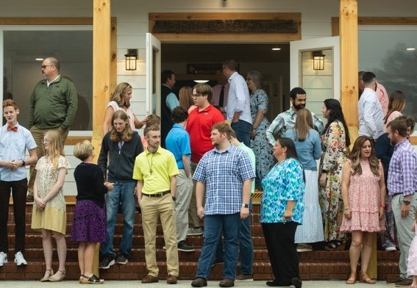
Welcome to Antioch!

January 22, 2023

Sunday

9:45 am - Sunday School
11:00 am - Worship Service
5:00 pm - Life Groups

Wednesday

6:00 - 7:30 pm - Nursery
6:00 - 7:30 pm - AWANA
& Worship Kidstyle
6:00 - 7:30 pm - Youth
6:00 - 7:30 pm - Adult Bible Studies

Soli Deo Gloria!


Announcements

Worship & Praise
Bless His Holy Name #27
Victory in Jesus
So Much God
**Dismiss for Children's Church**
Amazing Grace (My Chains are Gone)
Sermon
Sick
Rev. Paul Holcombe

Worship & Praise

Just As I Am #343

Benediction



* Our New Sunday Night Study begins today at 4pm. Join us for this 7-week series, Taming the Tongue: How the Gospel Transforms Our Talk. Please contact the church office or Pastor Paul to request a book for the class. If you are able to provide childcare please let us know.

* Valentine’s Banquet is Saturday,
February 11th @ 6pm for our annual “Loved Beyond Measure” celebration dinner. Everyone is welcome to this time of games, laughs and fellowship! Steak or chicken, along with baked potatoes, salad, and dessert will be served! Please RSVP by February 5th.




* WOM’s Local Mission Project is focused on the Isaiah 117 House. Items will be collected until March 1st.

* Dr. Grady McMurtry will be joining us Wednesday, April 19th. He will discuss Job, a book of science.



* Attention Parents! There has been a change to the ages for Nursery and Children’s Church. Nursery ages are birth – 3yrs old. Children’s Church ages are 4-7yrs old.

* Parents, our Next Generation Pastor candidate will be with us on Wednesday, January 25th. Please join us for a time to
meet and ask the candidate questions.

* Follow us for Youth updates:
Instagram: @ASM_BLAIRSVILLE
Facebook: @AntiochStudentMinistries
Remind Text: text @ASMILD to 81010



* Men’s Prayer Breakfast meets this Tuesday @ 7:30 am.

* The Choir wants your voice! Practices are Mondays @7pm.

* We offer two separate Ladies Bible Studies. Join us @10am on Tuesdays or @5:30pm on Thursdays. Contact the church office for more information.

* Women On Mission - meets every 2nd Tuesday of the month @ 3pm in the FLC Kitchen

* Adult Bible Studies on Wednesday @ 6pm.

* Conspicuous, the College & Career Life Group, meets Thursday 7-9pm. Contact the church office for more information.

* Ways to Give – Drop it in the offering plates at each door, By Mail, Online at antiochga.org, or text “wind4350” to 888-364-4483

