The Christian Life
Galatians 2:1-10

1. _______________ triggers
___________ (v 1-2)
2. (v 3-5) _____________ your
______________
3. Make _______ ______________
(v 6-9)
4. (v 10) Eagerly _____________ __________

04/30: Larry Davis – 772-473-0618

04/30: Roger & Deloria Conner
05/07: Jim & Bobbie Ackles

04/30- 9:30: Nancy Ellingsworth & Christina Pokrywa
9:45: Terri Linton & Pat Rudd
05/07- 9:30: Nancy Ellingsworth & Christina Pokrywa
10:45: Mona Kern & Annie Kintz

04/30 – Joanna Kirkpatrick & Jaceyallen Elliott Assistant – Caroline Karnes

05/07 – Sara Davis & Emily Floyd
Assistant – Lane Kennedy

04/23/23
Worship Attendance 171
Sunday School Attendance 101

Budget Goal per month $33,712.06
Given this Month $30,497.58
Given Last Week $5,812.07

Pastor: Rev. Paul Holcombe
Communications Coordinator: Duane Manders
Phone: (706) 745-4350
Email: office@antiochga.org

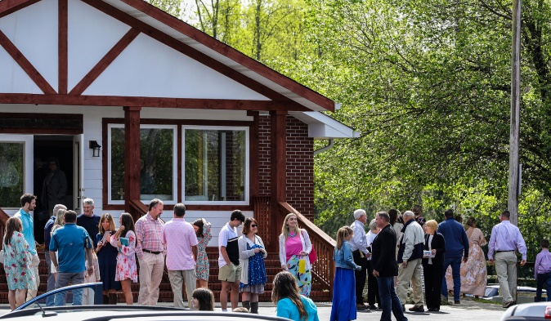
Welcome to Antioch!

April 30, 2023

Sunday

9:45 am - Sunday School
11:00 am - Worship Service
5:00 pm - Life Groups

Wednesday

6:00 - 7:30 pm - Nursery
6:00 - 7:30 pm - AWANA
& Worship Kidstyle
6:00 - 7:30 pm - Youth
6:00 - 7:30 pm - Adult Bible Studies

Soli Deo Gloria!

Announcements

Worship & Praise
Think About His Love
O How I Love Jesus #137
We’ve Come to Worship
**Dismiss for Children's Church**
Chain Breaker
Sermon
The Christian Life
Rev. Paul Holcombe

Worship & Praise

I Surrender All #486
Benediction

* Annie Armstrong Easter Offering collected was $4395! Thank you for your help!

* Graduate Drop-in Reception will be Sunday, May 7th @ 3pm in the FLC. Please join us to celebrate and encourage our graduates.

* Volleyball Tournament to support our Mission Team will be Saturday, May 20th at Noon. Entry fee is $60 per team. Come have fun and help us send out our missionaries!

* Homecoming is Sunday, May 21st. Join us as we celebrate another year of God’s grace.

* Promotion Sunday will be on Sunday,
June 4th. Students will be shown their new Sunday School class for the upcoming year.

* College Mission Trip to Connecticut is June 24-30th. If you are interested in helping one of our missionaries, please contact the church office.

* VBS is July 17-21. Mark your calendars!

* Youth Envelope Fundraiser is going on right now! Grab your envelope in the foyer.

* Youth Mission Trip is July 22-27. Stay tuned for details!

* Men’s Ministry Breakfast meets this Monday @ 7:30 am.

* The Choir wants your voice! Practices are Mondays @7pm. Practice in April will be on the 17th from 6:30 – 8:00pm.

* We offer three separate Ladies Bible Studies. Join us @10am on Tuesdays, 10am on Thursdays or @6:00pm on Thursdays. Contact the church office for more information.

* Women On Mission - meets every 2nd Tuesday of the month @ 3pm in the FLC Kitchen

* Adult Bible Studies on Wednesday @ 6pm.

* Conspicuous, the College & Career Life Group, meets Thursday 7-9pm. Contact the church office for more information.

* Ways to Give – Drop it in the offering plates at each door, By Mail, Online at antiochga.org, or text “wind4350” to 888-364-4483

