

Sermon Notes
1 Corinthians 12:4-7



11/12: David Floyd – 706-400-9307


11/12: Roger & Deloria Conner

11/19: Jim & Bobbie Ackles


11/12- 9:30: Nancy Ellingsworth & Holly Owenby
10:45: Mona Kern & Addison Kennedy

11/19- 9:30: Nancy Ellingsworth & DeeDee Siefken
10:45: Pat Rudd & Kelsey Cline



11/12 – Joanna Kirkpatrick & Jaceyallen Elliott
Assistant: Hannah Corley

11/19 – Sara Davis & Emily Floyd
Assistant: Lane Kennedy


11/05/23
Worship Attendance 148
Sunday School Attendance 80

Budget Goal per month $33,712.06
Given this Month $14,031.00
Given Last Week $14,031.00


Pastor: Prayerfully seeking our next Senior Pastor and Youth Pastor
Interim Pastor: David Ritcey
Communications Coordinator: Duane Manders
Worship Leader: Danita Kennedy
Phone: (706) 745-4350
Email: office@antiochga.org



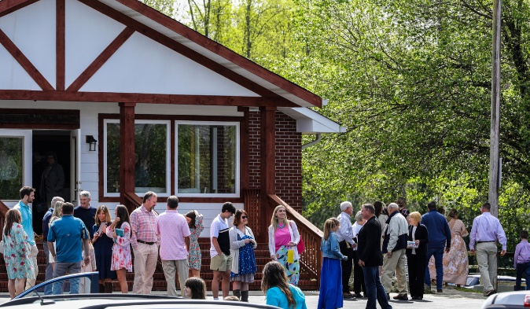
Welcome to Antioch!

November 12, 2023

Sunday

9:45 am - Sunday School
11:00 am - Worship Service

Wednesday

6:00 - 7:30 pm - Nursery
6:00 - 7:30 pm - AWANA
& Worship Kidstyle
6:00 - 7:30 pm - Youth
6:00 - 7:30 pm - Adult Bible Studies



Welcome/Announcements/Greeting Time

Bless His Holy Name
Worship & Praise
Pledges of Allegiance
Thank you to Veterans
Stand Up, Stand Up for Jesus #646
Count Your Blessings #771
Lift Up the Cross
**Dismiss for Children's Church**
Battle Belongs
Sermon
1 Corinthians 12:4-7
Rev. David Ritcey

Invitation

Only Trust Him #334
Benediction



* Family Connections Christmas – Today is the last day to make a donation to support the family adopted for Christmas through Union County Schools Family Connections.

* Women’s Ministry Craft Night – This Monday, Nov. 13th, @ 6:30 p.m. in the FLC. This month will be wreath making. Come out for fellowship and fun.

* Business Meeting/Church Celebration – Sunday, November 19th @ 4:00pm. Bring your favorite dessert to share.

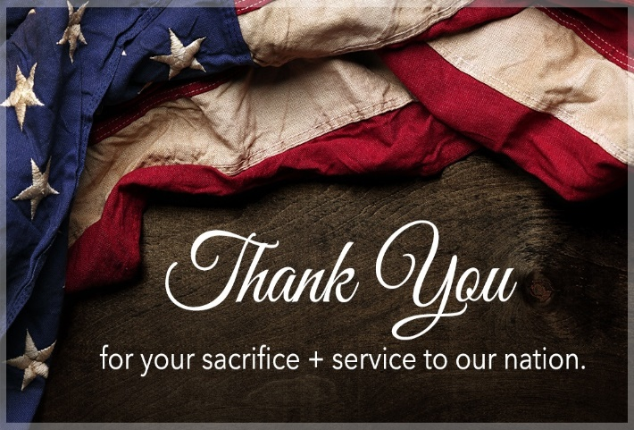

* Church Office – will be closed November 22-24 for Thanksgiving.

* Thanksgiving/Christmas Dinner – Sunday, December 3rd @ 4pm in the FLC.

* Wreaths Across America - Dec. 16th – Donations are $17.50, buy 2 get 3. We are now a designated location. We need names of veterans who were possibly missed last year. Nov. 28 is the order cutoff date.



* Meeks Park Fall 5K – ASM’s Fall 5K will be at Meek’s Park on Sunday, Nov. 12 at 3 p.m. This event will serve to allow our students the opportunity to fully fund the trips we take as a youth group. Please consider supporting them by offering a sponsorship.



* Men’s Ministry Breakfast meets this Monday @ 7:30 am.

* Choir – If you are interested in joining the choir please contact Danita Kennedy for details. Practice in Nov. will be on the 6th & 20th from 6:30 – 8:00pm.

* We offer two separate Ladies Bible Studies. Join us @10am on Tuesdays and @6:00pm on Thursdays in the FLC. Contact the church office for more information.

* Women On Mission - meets every 2nd Tuesday of the month @ 12:30pm in the FLC Kitchen. Mark your calendar for November 14th.

* Adult, Youth, & Children Activities & Bible Studies on Wednesday @ 6pm. Adults in the Sanctuary kids in the FLC.

* Ways to Give – Drop it in the offering plates at each door, by mail, online at antiochga.org, or text “wind4350” to 888-364-4483.

