

Sermon Notes
Joshua 2:8-24



12/31: David Floyd – 706-400-9307


12/31: Mick & Shirley Cox

01/07: Roger & Deloria Conner


12/31- 9:30: Nancy Ellingsworth & DeeDee Siefken
10:45: Pat Rudd & Kelsey Cline

01/07- 9:30: Nancy Ellingsworth & Christina Pokrywa
10:45: Mona Kern & Jaceyallen Elliott



12/31 – Megan Henry & Connie Collins
Assistant: Houston Henry

01/07 – Joanna Kirkpatrick & Mickey Ward
Assistant: Jayden Karnes


12/24/23
Worship Attendance 174
Sunday School Attendance

Budget Goal per month $33,712.06
Given this Month $28,230.46
Given Last Week $4,396.00


Pastor: Prayerfully seeking our next Senior Pastor and Youth Pastor
Interim Pastor: David Ritcey
Communications Coordinator: Duane Manders
Worship Leader: Danita Kennedy
Phone: (706) 745-4350
Email: office@antiochga.org



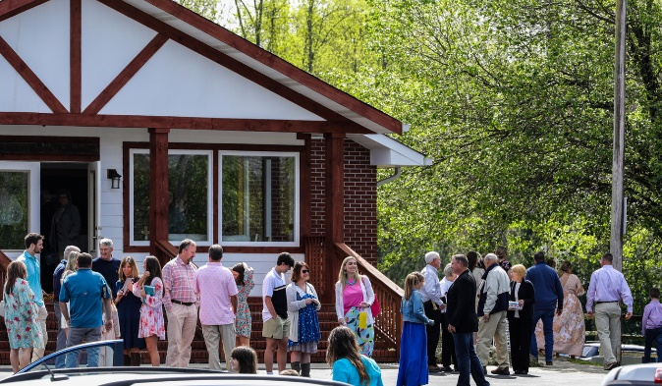
Welcome to Antioch!

December 31, 2023

Sunday

9:45 am - Sunday School
11:00 am - Worship Service

Wednesday

6:00 - 7:30 pm - Nursery
6:00 - 7:30 pm - AWANA
& Worship Kidstyle
6:00 - 7:30 pm - Youth
6:00 - 7:30 pm - Adult Bible Studies



Welcome/Announcements/Greeting Time

Fresh Anointing
Worship & Praise
Just a Closer Walk with Thee #607
What a Friend We have in Jesus #625
At the Cross
**Dismiss for Children's Church**
Build My Life
Sermon
Joshua 2:8-24
Rev. David Ritcey

Invitation

I Surrender All #486



* Lottie Moon Christmas Offering for International Missions is being collected from now until December 31st. Please pray about how you might help make our goal of $4000 a reality. We have received $4710!





* Strength to Stand Parent Meeting – Wednesday, January 10th @ 7:30pm in the Youth Room.

* Sunday School/Discipleship Town Hall – Sunday, January 28th after church. Lunch will be provided. The focus is “Be a Friend Worth Having/ Make Disciples”.

* Georgia Mountain Men’s Conference – February 3rd @ 9:00am @ Union County Fine Arts Center. Big time speakers and BBQ lunch to follow. Cost is $20. See Duane to sign up.



* Strength to Stand – January 13th – 15th




* Men’s Ministry Breakfast will not meet this week. We will meet this Tuesday, Jan. 2nd @ 7:30am in the FLC Kitchen

* Choir – If you are interested in joining the choir please contact Danita Kennedy for details. Practice in Jan. will be on the 8th & 22nd from 6:30 – 8:00pm.

* Ladies Bible Studies. Join us @10am on Tuesdays, Wednesdays @6pm and @6:00pm on Thursdays in the FLC. Contact the church office for more information.

* Women On Mission - meets every 2nd Tuesday of the month @ 12:30pm in the FLC Kitchen. Mark your calendar for January 9th.

* Adult, Youth, & Children Activities & Bible Studies on Wednesday @ 6pm in the FLC

* Ways to Give – Drop it in the offering plates at each door, by mail, online at antiochga.org, or text “wind4350” to 888-364-4483.

