Sermon Notes
1 Thessalonians 5:1-11

01/07: Mike Bittel – 706-835-7555

01/07: Roger & Deloria Conner

01/14: Jim & Bobbie Ackles

01/07- 9:30: Nancy Ellingsworth & Christina Pokrywa
10:45: Mona Kern & Jaceyallen Elliott

01/14- 9:30: Nancy Ellingsworth & Holly Owenby
10:45: Holly Owenby & Addison Kennedy

01/07 – Joanna Kirkpatrick & Mickey Ward
Assistant: Jayden Karnes

01/14 – Emily Hayden & Hope Haynes
Assistant: Lane Kennedy

12/31/23
Worship Attendance 149
Sunday School Attendance 68

Budget Goal per month $33,712.06
Given this Month $34,051.46
Given Last Week $5,821.00

Pastor: Prayerfully seeking our next Senior Pastor and Youth Pastor
Interim Pastor: David Ritcey
Communications Coordinator: Duane Manders
Worship Leader: Danita Kennedy
Phone: (706) 745-4350
Email: office@antiochga.org

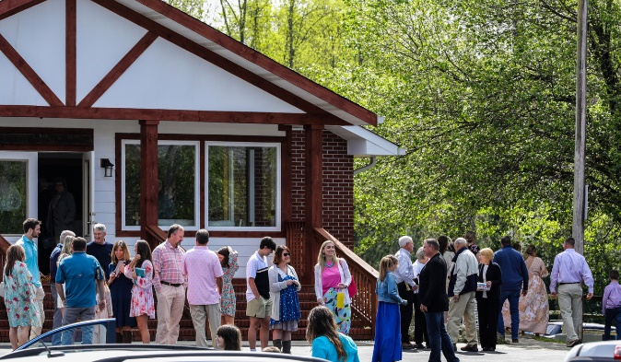
Welcome to Antioch!

January 07, 2024

Sunday

9:45 am - Sunday School
11:00 am - Worship Service

Wednesday

6:00 - 7:30 pm - Nursery
6:00 - 7:30 pm - AWANA
& Worship Kidstyle
6:00 - 7:30 pm - Youth
6:00 - 7:30 pm - Adult Bible Studies

Welcome/Announcements/Greeting Time

Family of God #681
Worship & Praise
When We All Get to Heaven #650
Sweet Bye-and-by #658
What We Believe
**Dismiss for Children's Church**
Hymn of Heaven
Sermon
1 Thessalonians 5:1-11
Rev. David Ritcey

Invitation

I Need Thee Every Hour #600

* Sunday School/Discipleship Town Hall – Sunday, January 28th after church. Led by PJ Dunn, who is a Discipleship Catalyst with the Georgia Baptist Mission Board. Lunch will be provided. The focus is “Be a Friend Worth Having/ Make Disciples”.

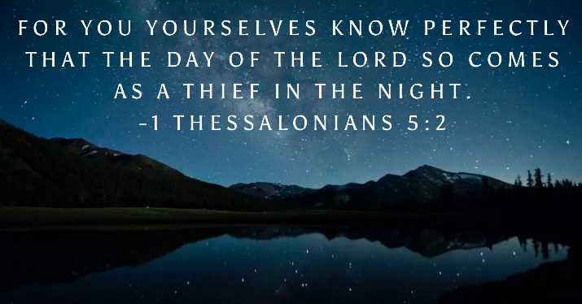

* Georgia Mountain Men’s Conference – February 3rd @ 9:00am @ Union County Fine Arts Center. Big time speakers and BBQ lunch to follow. Cost is $20. See Duane to sign up or scan the QR code below to take you directly the sign-up page.

* Strength to Stand – January 13th – 15th

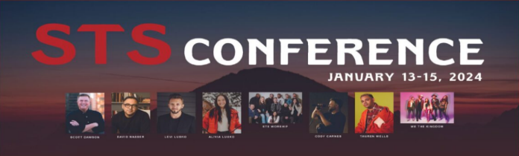

* Men’s Ministry Breakfast will not meet this week. We will meets every Monday @ 7:30am in the FLC Kitchen.

* Choir – If you are interested in joining the choir please contact Danita Kennedy for details. Practice in Jan. will be on the 8th & 22nd from 6:30 – 8:00pm.

* Ladies Bible Studies. Join us @10am on Tuesdays, Wednesdays @6pm and @6:00pm on Thursdays in the FLC. Contact the church office for more information.

* Women On Mission - meets every 2nd Tuesday of the month @ 12:30pm in the FLC Kitchen. Mark your calendar for January 9th.

* Adult, Youth, & Children Activities & Bible Studies on Wednesday @ 6pm in the FLC

* Ways to Give – Drop it in the offering plates at each door, by mail, online at antiochga.org, or text “wind4350” to 888-364-4483.

