

Sermon Notes
James 3:1-12



01/14: Gary Cook – 706-994-4902


01/14: Jim & Bobbie Ackles

01/21: Steve Drake & Gary Cook


01/14- 9:30: Nancy Ellingsworth & Holly Owenby
10:45: Holly Owenby & Addison Kennedy

01/21- 9:30: Nancy Ellingsworth & DeeDee Siefken
10:45: Kelsey Cline & Pat Rudd



01/14 – Emily Hayden & Hope Haynes
Assistant: Lane Kennedy

01/21 – DiAnne Bennett & Mickey Ward
Assistant: Jayden Karnes


01/07/24
Worship Attendance 129
Sunday School Attendance 62

Budget Goal per month $33,970.40
Given this Month $12,280.44
Given Last Week $12,280.44


Pastor: Prayerfully seeking our next Senior Pastor and Youth Pastor
Interim Pastor: David Ritcey
Communications Coordinator: Duane Manders
Worship Leader: Danita Kennedy
Phone: (706) 745-4350
Email: office@antiochga.org



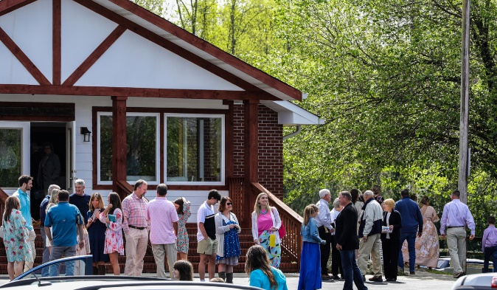
Welcome to Antioch!

January 14, 2024

Sunday

9:45 am - Sunday School
11:00 am - Worship Service

Wednesday

6:00 - 7:30 pm - Nursery
6:00 - 7:30 pm - AWANA
& Worship Kidstyle
6:00 - 7:30 pm - Youth
6:00 - 7:30 pm - Adult Bible Studies



Welcome/Announcements/Greeting Time

Open Our Eyes #459
Worship & Praise
Revive Us Again #719
I Love to Tell the Story #696
Goodness of God
**Dismiss for Children's Church**
Sermon
James 3:1-12
Rev. David Ritcey

Invitation

Only Trust Him #334



* Thursday Night Bible Study – will begin a new study on January 25th @ 5:30pm in the FLC. It will be “The Armor of God” by Priscilla Shirer. Cost of the book is $25. Sign-up sheet in the foyer.



* Sunday School/Discipleship Town Hall – Sunday, January 28th after church. Led by PJ Dunn, who is a Discipleship Catalyst with the Georgia Baptist Mission Board. Lunch will be provided. The focus is “Be a Friend Worth Having/ Make Disciples”.

* Widow’s Ministry – will meet on February 3rd @ 2pm in FLC kitchen. This meeting will be to discuss the ministry. See Donna Gurr for details.

* Georgia Mountain Men’s Conference – February 3rd @ 9:00am @ Union County Fine Arts Center. Big time speakers and BBQ lunch to follow. Cost is $20. See Duane to sign up or scan the QR code below to take you directly the sign-up page.





* Strength to Stand – January 13th – 15th

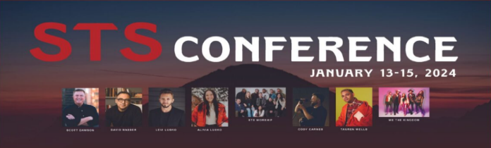


* Men’s Ministry Breakfast will not meet this week. We will meets every Monday @ 7:30am in the FLC Kitchen.

* Choir – If you are interested in joining the choir please contact Danita Kennedy for details. Practice in Jan. will be on the 22nd from 6:30 – 8:00pm.

* Ladies Bible Studies. Join us @10am on Tuesdays, Wednesdays @6pm and @5:30pm on Thursdays in the FLC. Contact the church office for more information.

* Women On Mission - meets every 2nd Tuesday of the month @ 12:30pm in the FLC Kitchen. Mark your calendar for February 13th.

* Adult, Youth, & Children Activities & Bible Studies on Wednesday @ 6pm in the FLC

* Ways to Give – Drop it in the offering plates at each door, by mail, online at antiochga.org, or text “wind4350” to 888-364-4483.

