Sermon Notes
Psalm 100:1-3

01/21: Kevin Payne – 706-400-1591

01/21: Steve Drake & Gary Cook

01/28: Mick & Shirley Cox

01/21- 9:30: Nancy Ellingsworth & DeeDee Siefken
10:45: Kelsey Cline & Pat Rudd

01/28- 9:30: Nancy Ellingsworth & Susan Karnes
10:45: Donna Thompson & Sara Bittel

01/21 – DiAnne Bennett
Assistant: Jayden Karnes

01/28 – Megan Henry & Connie Collins
Assistant: Houston Henry

01/14/24
Worship Attendance 143
Sunday School Attendance 86

Budget Goal per month $33,970.40
Given this Month $15,787.70
Given Last Week $3,507.26

Pastor: Prayerfully seeking our next Senior Pastor and Youth Pastor
Interim Pastor: David Ritcey
Communications Coordinator: Duane Manders
Worship Leader: Danita Kennedy
Phone: (706) 745-4350
Email: office@antiochga.org

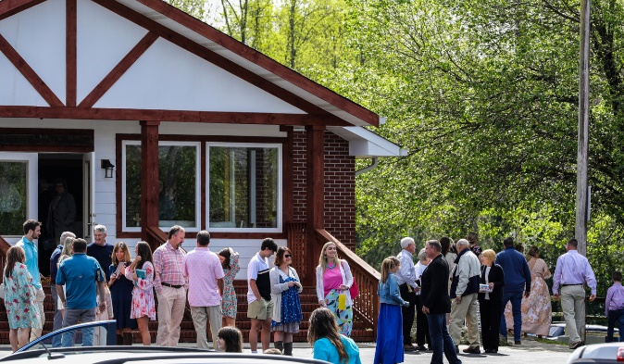
Welcome to Antioch!

January 21, 2024

Sunday

9:45 am - Sunday School
11:00 am - Worship Service

Wednesday

6:00 - 7:30 pm - Nursery
6:00 - 7:30 pm - AWANA
& Worship Kidstyle
6:00 - 7:30 pm - Youth
6:00 - 7:30 pm - Adult Bible Studies

We’ve Come to Worship

Welcome/Announcements

Baptism

He is Lord #269
Worship & Praise
Victory in Jesus #352
How Great Thou Art #33
This is How it Feels to be Free
Cleansed
**Dismiss for Children's Church**
Special Music
Sermon
Psalm 100:1-3
Rev. David Ritcey

Invitation

God is So Good #50

* Giving Statements – The giving statements from last year are in your boxes by the office door.

* Thursday Night Bible Study – will begin a new study on January 25th @ 5:30pm in the FLC. It will be “The Armor of God” by Priscilla Shirer. Cost of the book is $25. Sign-up sheet in the foyer.

* Sunday School/Discipleship Town Hall – For all Sunday School/Small Groups teachers, leaders and anyone interested in helping with Sunday School or Small Groups on Sunday, January 28th after church. Led by PJ Dunn, who is a Discipleship Catalyst with the Georgia Baptist Mission Board. Lunch will be provided. The focus is “Be a Friend Worth Having/ Make Disciples”. We will also have a guest speaker, Steve Foster, for the worship service

* Widow’s Ministry – will meet on February 3rd @ 2pm in FLC kitchen. This meeting will be to discuss the ministry. See Donna Gurr for details.

* Georgia Mountain Men’s Conference – February 3rd @ 9:00am @ Union County Fine Arts Center. Big time speakers and BBQ lunch to follow. Cost is $20. See Duane to sign up or scan the QR code below to take you directly the sign-up page.

* Calling ALL Women! Save March 23rd, 2024 for a one-day Woman’s Retreat at Vogel State Park! More details coming very soon!

* DNOW will be March 1-2. The theme this year is Creator, Savior, King.

* Men’s Ministry Breakfast meets every Monday @ 7:30am in the FLC Kitchen.

* Choir – If you are interested in joining the choir please contact Danita Kennedy for details. Practice in Jan. will be on the 22nd from 6:30 – 8:00pm.

* Ladies Bible Studies. Join us @10am on Tuesdays, Wednesdays @6pm and @5:30pm on Thursdays in the FLC. Contact the church office for more information.

* Women On Mission - meets every 2nd Tuesday of the month @ 12:30pm in the FLC Kitchen. Mark your calendar for February 13th.

* Adult, Youth, & Children Activities & Bible Studies on Wednesday @ 6pm in the FLC

* Ways to Give – Drop it in the offering plates at each door, by mail, online at antiochga.org, or text “wind4350” to 888-364-4483.

