Sermon Notes
John 17:9-24

02/04: Larry Davis – 772-473-0618

02/04: Roger & Deloria Conner

02/11: Jim & Bobbie Ackles

02/04- 9:30: Nancy Ellingsworth & Christina Pokrywa
10:45: Mona Kern & Kelsey Cline

02/11- 9:30: Nancy Ellingsworth & Holly Owenby
10:45: Holly Owenby & Addison Kennedy

02/04 – Joanna Kirkpatrick & Jaceyallen Elliott Assistant: Hannah Corley

02/11 – ??????????? & Hope Haynes
Assistant: Lane Kennedy

01/28/24
Worship Attendance 153
Sunday School Attendance 76

Budget Goal per month $33,970.40
Given this Month $27,002.60
Given Last Week $5,617.36

Pastor: Prayerfully seeking our next Senior Pastor and Youth Pastor
Interim Pastor: David Ritcey
Communications Coordinator: Duane Manders
Worship Leader: Danita Kennedy
Phone: (706) 745-4350
Email: office@antiochga.org

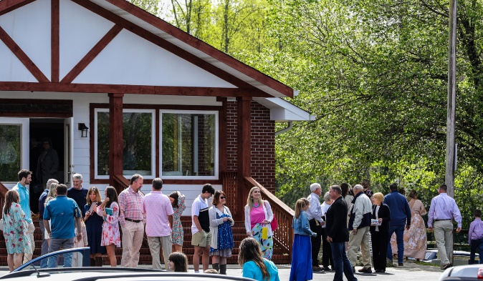
Welcome to Antioch!

February 04, 2024

Sunday

9:45 am - Sunday School
11:00 am - Worship Service

Wednesday

6:00 - 7:30 pm - Nursery
6:00 - 7:30 pm - AWANA
& Worship Kidstyle
6:00 - 7:30 pm - Youth
6:00 - 7:30 pm - Adult Bible Studies

Welcome/Announcements

Be Welcome (chorus)
Worship & Praise
He Lives #262
It is Well with My Soul #554
Stronger
**Dismiss for Children's Church**
Who You Say I Am
Sermon
John 17:9-24
Rev. David Ritcey

Invitation

Sweet Hour of Prayer #632

* Valentine’s Dinner – “Loved Beyond Measure.” February 10th @ 6:00pm in the FLC.

* Ladies Craft Night at the FLC 6:30 p.m. Monday February 12. Fun with "abstract heart" painting on canvas led by Katey and Jessica. Katey will bring all materials, please bring $15 to cover her cost.

* Calling ALL Women! Save March 23rd, 2024 for a one-day Woman’s Retreat at Vogel State Park! More details coming very soon!

* DNOW will be March 1-2. The theme this year is Creator, Savior, King.

* Men’s Ministry Breakfast meets every Monday @ 7:30am in the FLC Kitchen.

* Choir – If you are interested in joining the choir please contact Danita Kennedy for details. Practice in Feb. will be on the 5th & 19th from 6:30 – 8:00pm.

* Ladies Bible Studies. Join us @10am on Tuesdays, Wednesdays @6pm and @5:30pm on Thursdays in the FLC. Contact the church office for more information.

* Women On Mission - meets every 2nd Tuesday of the month @ 12:30pm in the FLC Kitchen. Mark your calendar for February 13th.

* Adult, Youth, & Children Activities & Bible Studies on Wednesday @ 6pm in the FLC

* Ways to Give – Drop it in the offering plates at each door, by mail, online at antiochga.org, or text “wind4350” to 888-364-4483.

