

Are You All In?
Romans 12:1-2



01/28: Steve Drake – 706-897-3754


01/28: Mick & Shirley Cox

02/04: Roger & Deloria Conner


01/28- 9:30: Nancy Ellingsworth & Susan Karnes
10:45: Donna Thompson & Sara Bittel

02/04- 9:30: Nancy Ellingsworth & Christina Pokrywa
10:45: Mona Kern & Jaceyallen Elliott



01/28 – Megan Henry & Connie Collins Assistant: Houston Henry

02/04 – Joanna Kirkpatrick & Jaceyallen Elliott
Assistant: Hannah Corley


01/21/24
Worship Attendance 193
Sunday School Attendance 76

Budget Goal per month $33,970.40
Given this Month $21,385.24
Given Last Week $5,597.54


Pastor: Prayerfully seeking our next Senior Pastor and Youth Pastor
Interim Pastor: David Ritcey
Communications Coordinator: Duane Manders
Worship Leader: Danita Kennedy
Phone: (706) 745-4350
Email: office@antiochga.org



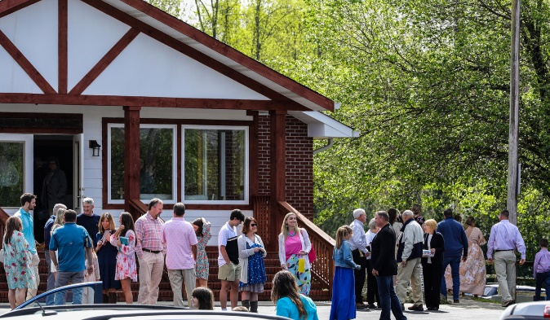
Welcome to Antioch!

January 28, 2024

Sunday

9:45 am - Sunday School
11:00 am - Worship Service

Wednesday

6:00 - 7:30 pm - Nursery
6:00 - 7:30 pm - AWANA
& Worship Kidstyle
6:00 - 7:30 pm - Youth
6:00 - 7:30 pm - Adult Bible Studies



Welcome/Announcements

Lead On Good Shepherd
Worship & Praise
Tis So Sweet to Trust in Jesus #560
I’d Rather Have Jesus #456
One Day
**Dismiss for Children's Church**
Firm Foundation
Sermon
Are You All In?
Romans 12:1-2
Rev. Steve Foster

Invitation

I Surrender All #486



* Thursday Night Bible Study – will begin a new study on February 1st @ 5:30pm in the FLC. It will be “The Armor of God” by Priscilla Shirer. Cost of the book is $25. Sign-up sheet in the foyer.

* Sunday School/Discipleship Town Hall – For all Sunday School/Small Groups teachers, leaders and anyone interested in helping with Sunday School or Small Groups is today after church. It will be led by PJ Dunn, who is a Discipleship Catalyst with the Georgia Baptist Mission Board. Lunch will be provided. The focus is “Be a Friend Worth Having/ Make Disciples”. We will also have a guest speaker, Steve Foster, for the worship service

* Widow’s Ministry – will meet on February 3rd @ 2pm in FLC kitchen. This meeting will be to discuss the ministry. See Donna Gurr for details.

* Georgia Mountain Men’s Conference – February 3rd @ 9:00am @ Union County Fine Arts Center. Big time speakers and BBQ lunch to follow. Cost is $20. See Duane to sign up or scan the QR code below to take you directly the sign-up page.

* Calling ALL Women! Save March 23rd, 2024 for a one-day Woman’s Retreat at Vogel State Park! More details coming very soon!

* Ladies Craft Night at the FLC 6:30 p.m. Monday February 12. Fun with "abstract heart" painting on canvas led by Katey and Jessica. Katey will bring all materials, please bring $15 to cover her cost.



* DNOW will be March 1-2. The theme this year is Creator, Savior, King.




* Men’s Ministry Breakfast meets every Monday @ 7:30am in the FLC Kitchen.

* Choir – If you are interested in joining the choir please contact Danita Kennedy for details. Practice in Feb. will be on the 5th & 19th from 6:30 – 8:00pm.

* Ladies Bible Studies. Join us @10am on Tuesdays, Wednesdays @6pm and @5:30pm on Thursdays in the FLC. Contact the church office for more information.

* Women On Mission - meets every 2nd Tuesday of the month @ 12:30pm in the FLC Kitchen. Mark your calendar for February 13th.

* Adult, Youth, & Children Activities & Bible Studies on Wednesday @ 6pm in the FLC

* Ways to Give – Drop it in the offering plates at each door, by mail, online at antiochga.org, or text “wind4350” to 888-364-4483.

