

Sermon Notes
“A Renewed Vision”
1 Corinthians 2:9,
Nehemiah 1:3,4,5-7,11



06/09: Steve Drake – 706-897-3754


06/09: Steve Drake & Gary Cook

06/16: Mick & Shirley Cox


06/09- 9:30: Nancy Ellingsworth & Holly Owenby
10:45: Nancy Ellingsworth & Holly Owenby

06/16- 9:30: Nancy Ellingsworth & DeeDee Siefken
10:45: Holly Owenby & Jaceyallen Elliott



06/09 – Crystal Telford & Kelley Manders
Assistant: Lane Kennedy

06/16 – Alicia Payne & Hope Haynes
Assistant: Holden Payne


06/02/24
Worship Attendance 141
Sunday School Attendance 75

Budget Goal per month $33,970.40
Given this Month $12,406.74
Given Last Week $12,406.74


Pastor: Sean Nix
Worship Leader: Danita Kennedy
Communications Coordinator: Duane Manders
Phone: (706) 745-4350
Email: office@antiochga.org



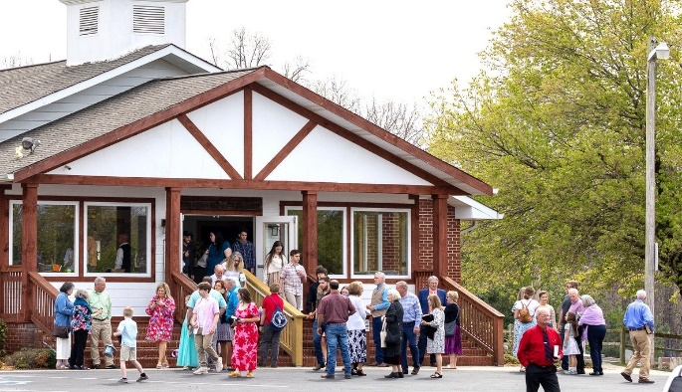
Welcome to Antioch!

June 09, 2024

Sunday

9:45 am - Sunday School
11:00 am - Worship Service

Wednesday

6:00 - 7:30 pm - Nursery
6:00 - 7:30 pm - AWANA
& Worship Kidstyle
6:00 - 7:30 pm - Youth
6:00 - 7:30 pm - Adult Bible Studies



Welcome/Announcements/Prayer

VBS Promo
Praise & Worship
Raise a Hallelujah
God is So Good #50
Lord, We Praise You #135
Goodness of God
Dismiss for Children's Church
Firm Foundation
Sermon
“A Renewed Vision”
1 Corinthians 2:9,
Nehemiah 1:3,4,5-7,11
Rev. Sean Nix

Invitation

Only Trust Him #334



* Tuesday Morning Ladies Bible Studies – A 2 new studies will start on June 18th. Annie Kintz will be leading a study called “The Bonfire” meeting in the FLC Kitchen. Contact Annie @ 706-897-4564 to sign up. Donna Gurr will be leading a study called “Alive” meeting in FLC 1. These studies meet every Tuesday morning @ 10am.

* Leadership Vision Night – On June 19th @ 6:00pm we will have Leadership Vision Night in the FLC Kitchen.

* Vacation Bible School – June 26th – 28th
This year’s theme is “Breaker Rock Beach” challenging children to be “Transformed by the renewing of your mind.” Romans 12:2. More information coming soon!

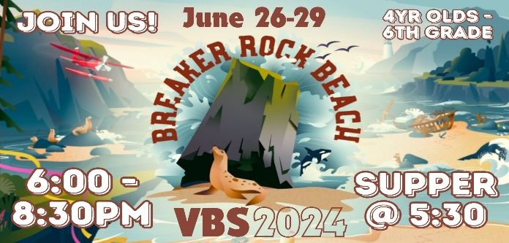

* Save the Date! – Wednesday, July 17th @ 6pm, we will have a church wide picnic @ Meeks Park Pavilion 3 (near the playground). The church will provide the hamburgers & hotdogs. Bring your favorite picnic side or dessert.





* Teen Valley Ranch – Our children & youth will be headed to TVR July 29th – August 3rd. There are 7 adults & 35 kids going. If you would like to sponsor a child that would be appreciated. The price per child is $450. Anyone who wants could donate any amount towards that.


* Men’s Ministry Breakfast meets every Monday @ 7:30am in the FLC Kitchen.

* Choir – If you are interested in joining the choir please contact Danita Kennedy for details. Practice in June will be on 6/17 from 6:30 – 8:00pm.

* Ladies Bible Studies: Join us @10am on Tuesdays, Wednesdays @6pm and @5:30pm on Thursdays in the FLC. Contact the church office for more information.

* Women On Mission - will be taking the summer off. We will start back up on the 2nd Tuesday of September, 9/10, @ 12:30 in the FLC.

* Widows Ministry – Will meet on the second Thursday in June for lunch @ noon. Next meeting June 13th .

* Adult, Youth, & Children Activities & Bible Studies on Wednesday @ 6pm in the FLC

* Ways to Give – Drop it in the offering plates at each door, by mail, online at antiochga.org, or text “wind4350” to 888-364-4483.

