

Sermon Notes
Ephesians 3:20-21



05/19: David Floyd – 706-400-9307


05/19: Mick & Shirley Cox

05/26: Roger & Deloria Conner


05/19- 9:30: Nancy Ellingsworth & DeeDee Siefken
10:45: Bethany Manders & Jaceyallen Elliott

05/26- 9:30: Nancy Ellingsworth & Susan Karnes
10:45: Donna Thompson & Sara Bittel



05/19 – Mickey Ward
Assistant: Jayden Karnes

05/26 – Megan Henry & Connie Collins
Assistant: Scout Henry


05/12/24
Worship Attendance 174
Sunday School Attendance 86

Budget Goal per month $33,970.40
Given this Month $14,363.75
Given Last Week $5,960.11


Pastor: Sean Nix
Worship Leader: Danita Kennedy
Communications Coordinator: Duane Manders
Phone: (706) 745-4350
Email: office@antiochga.org



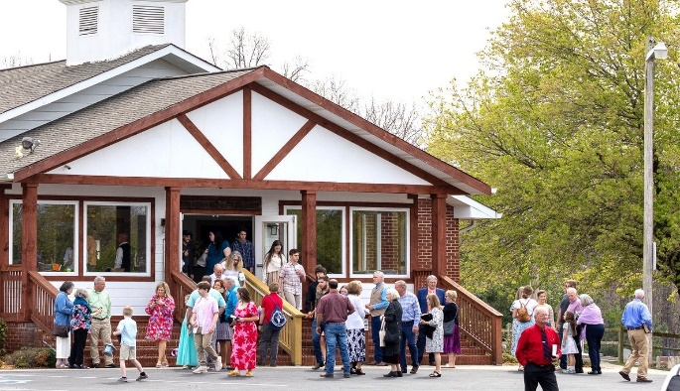
Welcome to Antioch!

May 26, 2024

Sunday

9:45 am - Sunday School
11:00 am - Worship Service

Wednesday

6:00 - 7:30 pm - Nursery
6:00 - 7:30 pm - AWANA
& Worship Kidstyle
6:00 - 7:30 pm - Youth
6:00 - 7:30 pm - Adult Bible Studies



Tis So Sweet/Leaning on the Everlasting Arms

Baptism

Welcome/Announcements

Worship & Praise
Holy Ground #114
When We All Get to Heaven #650
O How I Love Jesus #137
Because of Jesus
Dismiss for Children's Church
Come Jesus Come
Sermon
Ephesians 3:20-21
Rev. David Ritcey

Invitation

Just As I Am (choir version)
Because He Lives



* Tuesday Morning Ladies Bible Study – A new study will start on June 18th with Annie Kintz facilitating

“The Bonfire”. This study meets every Tuesday morning @ 10am in the FLC kitchen. This new study will examine what Scripture says from Genesis to Revelation. Come join us for fellowship and dive into what Scripture says.
Contact Annie @ 706-897-4564 to sign up.

* 183rd Homecoming – Today we will celebrate Antioch’s 183rd Homecoming. This will also be David & Laura Ritcey’s last Sunday with us. Let us thank David & Laura for their faithful ministry here at Antioch!

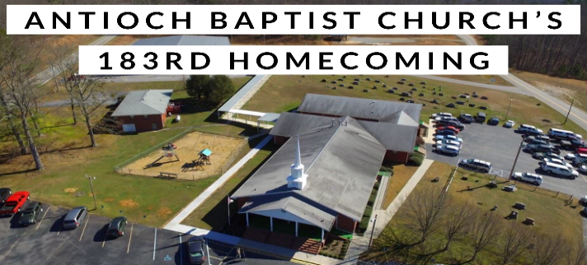

* Vacation Bible School – June 26th – 29th
This year’s theme is “Breaker Rock Beach” challenging children to be “Transformed by the renewing of your mind.” Romans 12:2. More information coming soon!





2024 High School Graduates

Zoe Dubé – Mountain Area Christian Academy
Addison Kennedy – Union County High School
Reece Manders – Union County High School
Shawn Pokrywa – Union County High School


* Men’s Ministry Breakfast meets every Monday @ 7:30am in the FLC Kitchen.

* Choir – If you are interested in joining the choir please contact Danita Kennedy for details. Practice in May will be on 5/20 from 6:30 – 8:00pm.

* Ladies Bible Studies: Join us @10am on Tuesdays, Wednesdays @6pm and @5:30pm on Thursdays in the FLC. Contact the church office for more information.

* Women On Mission - will be taking the summer off. We will start back up on the 2nd Tuesday of September, 9/10, @ 12:30 in the FLC.

* Widows Ministry – Meets every first Thursday for lunch @ noon. Next meeting June 6th.

* Adult, Youth, & Children Activities & Bible Studies on Wednesday @ 6pm in the FLC

* Ways to Give – Drop it in the offering plates at each door, by mail, online at antiochga.org, or text “wind4350” to 888-364-4483.

